
Nile University
School of Information Technology and Computer Science
Program of Computer Science

Diabetes Management System (DMS)

CSCI495 Senior Project I
Submitted in Partial Fulfilment of the Requirements
For the bachelor’s degree in information technology and computer science
Computer Science

Submitted by
Ahmed Eid Kamel | 202001842
Abdullah Mohamed El Badawy | 202001820
Mohamed Yasser Abo Shama | 202001242
Mohamed Assem Zedan | 202001886
Mostafa Nabil Mostafa | 202000756

Supervised by

Dr. Nashwa Abdelbaki

Giza – Egypt
Spring 2024

Acknowledgment

We extend our deepest gratitude to our supervisor, Dr. Nashwa Abdelbaki, for her unwavering support, insightful guidance, and dedicated involvement at every project stage. Her continuous and professional support has been invaluable. We also wish to express our heartfelt thanks to Dr. Mohamed from the Nile University Clinic, whose readiness to assist with any medical inquiries has been greatly appreciated.

Abstract

The diabetes management system is an extensive self-care platform designed to streamline diabetes management and empower users in effective condition control. By encompassing pivotal features such as user registration, authentication, data monitoring, meal planning and nutrition guidance, insulin management tools, test report interpretation, and an interactive communication chat section, the system aims to address the multifaceted aspects of diabetes comprehensively. The driving force behind this system's development is to equip patients with tools for more effective self-management that elevates their quality of life and fosters a sense of control over their health. The system aims to guide individuals in tracking blood sugar levels, managing dietary and exercise habits, adhering to medication regimens, and receiving personalized recommendations and medical advice. By amalgamating these features, the diabetes management system assists in catalyzing a paradigm shift in self-care practices, actively contributing to improved health outcomes for individuals navigating life with diabetes.

Keywords: Diabetes mellitus, Type1, Type 2, Gestational diabetes, Pre-diabetes, Insulin, Meal planning, Treatment planning, Recommendation system, Blood sugar levels, Personal health record

List of contents
Chapter 1 1
Introduction 1
1.1 Background 1
1.2 Motivation 3
1.3 Objectives 4
1.4 Scope 6
1.5 Significance of Study 7
Chapter 2 8
Related Work 8
2.1 Introduction to Literature Review 8
2.2 Historical Perspective 9
2.3 Theoretical Framework 10
2.5 Current State of the Field 13
Chapter 3 14
Materials and Methods 14
3.1 System Description 14
3.2 System Requirements 15
3.3 Research Design 17
3.4 Architectural Design 24
3.5 Data Design 30
3.6 Interaction Design 39

Chapter 4 41
Implementation and Preliminary Results 41
4.1 Programming Languages and Tools 41
4.2 Code Structure 44
4.3 Data Structures and Databases 45
4.3.1 Data Structures 45
4.3.2 Databases 47
Chapter 5 59
Discussion 59
5.1 Interpretation of Results 59
5.2 Comparison with Previous Studies 61
5.3 Limitations 62
Chapter 6 63
Conclusion and Future Work 63
6.1 Summary of Findings 63
6.2 Future Work 64
References 65

List of Figures

Figure 1 Explanation of diabetes 2
Figure 2: The development of anti-diabetic medications. 9
Figure 3 MySugar 13
Figure 4 One drop app 13
Figure 5 Dexcom Clarity 13
Figure 6 A simple photo of the use case 15
Figure 7 System diagram 24
Figure 8 Diabetes Monitoring 28
Figure 9 Dataset graph 30
Figure 10 Flowchart of the system 40
Figure 11 Login page 48
Figure 12 Sign Up Page 49
Figure 13 Data Entry page 50
Figure 14 Diabetes Follow-Up Page 50
Figure 15 Exercises Page 51
Figure 16 Instruction Page 52
Figure 17 Information Insertion 53
Figure 18 Treatment plan Page 54
Figure 19 Diet plan page 55
Figure 20 Patient Information Page 56
Figure 21 Chatbot 58

List of Abbreviations

DMS | Diabetes Management System
DM | Diabetes Mellitus
PHR | Personal Health Record
BMI | Body Mass Index
AI | Artificial Intelligence
NLP | Natural Language Processing
RS | Recommendation System
CGM | Continues Glucose Monitoring
OCR | Optical Character Recognition

Chapter 1

Introduction

Background

Diabetes is a chronic medical condition characterized by the body's inability to regulate blood sugar levels effectively. Preventing or managing diabetes is crucial to mitigating health risks. The main danger of diabetes is the lack of a definitive cure. While insulin therapy is necessary to maintain blood sugar levels and prevent complications, it must be given according to precise doses and schedules determined by your healthcare provider. Diabetes remains a global health challenge, with patients facing high costs and serious complications. In the 21st century, artificial intelligence (AI) has emerged as a transformative force in diabetes care. Advanced AI algorithms analyze massive amounts of health data, enabling the development of personalized treatment plans, proactive blood sugar management, and comprehensive chatbot support. However, integrating AI into diabetes management requires careful attention to data privacy and algorithmic bias. Using AI will enhance diabetes care, improve patient outcomes, and potentially reduce the overall impact of this prevalent disease.

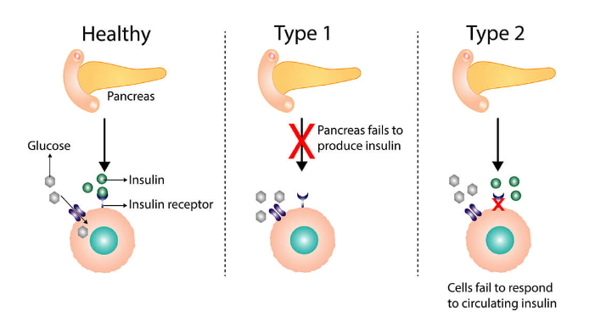
Figure 1 Explanation of diabetes

There are several types of diabetes mellitus

- Type 1 diabetes: occurs when the immune system mistakenly attacks and destroys beta cells in the pancreas. This permanent damage results in the body producing too little insulin. Often diagnosed in children and young adults, it requires insulin injections or insulin pumps to control blood sugar levels. 5-10% of people with diabetes have type 1, and symptoms develop quickly. Patients must take insulin daily.

- Type 2 diabetes: occurs when the body stops producing enough insulin. It is frequently caused by lifestyle factors such as obesity, unstable behavior, and poor food intake. It may be controlled by lifestyle changes, including consistent exercise, eating a balanced diet, managing weight, and using insulin or oral medicines. About 90-95% of individuals with diabetes have type 2 diabetes.

- Gestational diabetes: is a condition affecting some pregnant women without diabetes due to hormonal changes during pregnancy. This condition increases blood sugar levels and increases the risk of developing type 2 diabetes. It's crucial to make dietary changes, exercise regularly, and potentially use medications.

- Prediabetes: it is a condition in which blood sugar levels are higher than normal but not yet at the threshold for a diagnosis of type 2 diabetes. This serves as a warning sign indicating an increased risk of developing type 2 diabetes.

- Other types of diabetes: Monogenic diabetes is caused by damage to the pancreas. There are many other rare types of diabetes, such as type 3C and latent autoimmune diabetes in adults (LADA), and these types are rare.

1.2 Motivation
Over the past few years, the number of people with diabetes has increased significantly. Therefore, there are many reasons for creating a program for diabetics, including:

Guidance diabetics manage their condition more effectively
Diabetes is a complex condition requiring careful management of blood sugar, diet, exercise, and medication. The system can help users track these factors, log food intake and exercise, and complication prevention.

Personalized Recommendations
The system can utilize user data analysis to provide personalized recommendations for diabetes management, including tailored suggestions for medication adjustments, lifestyle changes, and other relevant aspects.

Education and Awareness
A chat feature with answers reviewed by qualified healthcare professionals can raise awareness and educate patients.

Preventing Complications
Encouraging healthy habits, early diagnosis of complications, and educating about risk factors can prevent long-term issues like neuropathy, retinopathy, and cardiovascular disease.

1.3 Objectives
The diabetes management system improves patient care with easy-to-use tools. There are alot of objectives for creating this system:
- Enhancing patient diabetes management with streamlined efficiency by integrating user-friendly tools. This optimization simplifies user experience and offers accessible tools for effective diabetes management. Ensures ease of navigation and interaction, facilitating users to monitor and control their conditions more efficiently.

- Cater to every facet of diabetes self-care, ensuring that users have the resources and support required for effective health management. Individuals can make informed decisions about treatment, nutrition, and overall lifestyle.

- Maintaining the highest standards of data privacy and confidentiality by incorporating innovative secure user registration and authentication protocols.

- The diabetes management system offers personalized meal planning and nutrition recommendations based on the user's health profile and dietary preferences. This approach ensures that the recommendations align with individual health needs, aiming for optimal health outcomes.

- Enable seamless input of test reports for patients, ensuring effortless data entry and subsequent validation of accuracy. This streamlined process not only simplifies the user experience but also ensures that the information input is thoroughly checked and interpreted by recognized medical standards.

- Provide a chat interface with a Natural Language Processing (NLP) system that categorizes and comprehends user queries, generating accurate and contextually relevant responses to address patients' inquiries effectively.

1.4 Scope

The scope of a Diabetes Management System (DMS) defines the project's boundaries, outlining what features and functionalities will be included and excluded. For DMS development to be successful, resources to be allocated effectively, and for the result to satisfy user demands, a clear scope must be defined. Key functionalities encompassed within the realm of a Diabetes Management System (DMS) typically include:

- Blood glucose monitoring: Real-time tracking of blood sugar levels is possible by integration with glucometers or continuous glucose monitoring (CGM) devices.

- Data logging and analysis: To find patterns and improve diabetes care, detailed tracking of blood sugar trends, food information, activity data, and medication adherence is done.

- User requirements and priorities: Addressing the needs and difficulties experienced by individuals with diabetes in managing their disease should be the main priority.

- Advanced analytics and customization: Machine learning algorithms offer suggestions and insights that are specific to each user based on their data. Utilizing AI algorithms and predictive analytics can help identify patterns in glucose levels, anticipate potential complications, and recommend adjustments to treatment plans.

Focus Area
Careful study has been done to focus on important points:
- Facilitating the website system for the user and providing many options for the user to enter his data.
- Providing the best diet and best treatment regimen according to the patient’s condition.
- Setting up a chat feature to answer any patient’s inquiry.
- Providing prevention methods for pre-diabetic patients.

1.5 Significance of the Study

The Diabetes Management System (DMS) is a platform designed to empower individuals living with diabetes. DMS revolves around the user, placing their needs and preferences at the forefront of its mission. This innovative platform offers a seamless and intuitive interface, making self-care solutions accessible to all. One of its features lies in its ability to consolidate and analyze data from various sources. By using this information, DMS provides personalized recommendations, empowering users to make informed choices about their diabetes management journey. Whether users opt to manually input data or upload lab test images, DMS ensures a meticulous examination process. Through comprehensive analysis, the system accurately assesses the presence or absence of diabetes, laying the groundwork for tailored treatment plans and dietary guidance. The platform enhances both accuracy and efficacy in diabetes management, all while optimizing the user experience.

Chapter 2

Related Work

2.1 Introduction to Literature Review

This document delves into the evolution and deployment of a comprehensive diabetes management system, underscoring the global prevalence of diabetes. It sheds light on the obstacles that individuals encounter in navigating the condition, including the necessity for lifestyle modifications and adherence to intricate treatment protocols. Central to this system is an array of features aimed at empowering users. From user registration to personalized health record management, data monitoring, meal planning, insulin regulation tools, test result interpretation, and an interactive chat interface, each facet is meticulously crafted to facilitate blood sugar tracking, dietary and exercise management, medication adherence, and tailored recommendations. Furthermore, the document explores the historical narrative of diabetes management, tracing its trajectory from the seminal discovery of insulin to the contemporary fusion of artificial intelligence (AI) into diabetes care paradigms. It underscores the consequences of uncontrolled diabetes. In navigating these challenges, the document underscores the imperative of lifestyle adjustments and steadfast adherence to multifaceted treatment modalities, recognizing the inherent difficulties that some individuals may encounter along this journey.

2.2 Historical Perspective
The field of diabetes management has seen significant advancements over the years. One feature was the discovery of insulin in the 1920s, which revolutionized the treatment of type 1 diabetes. The development of oral antidiabetic medications in the 1950s and 1960s provided alternative treatment options for type 2 diabetes. The introduction of portable blood glucose monitoring devices in the 1970s and 1980s allowed individuals to monitor their blood sugar levels at home. The advent of continuous glucose monitoring (CGM) systems in the early 2000s provided real-time glucose monitoring and comprehensive insights. In recent years, technological advances have led to the integration of mobile applications, wearable devices, and cloud-based platforms, empowering individuals to track their glucose levels, monitor their lifestyle habits, and receive personalized recommendations for better management.
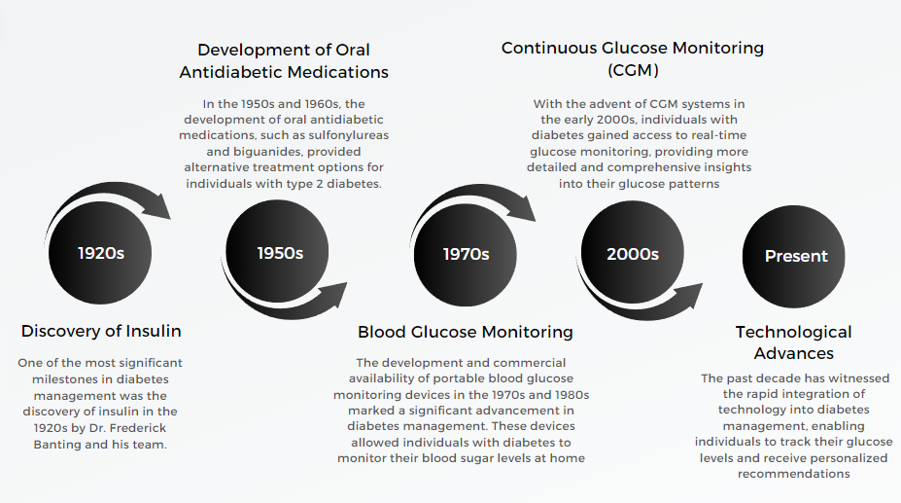
Figure 2: The development of anti-diabetic medications.

2.3 Theoretical Framework

Developing a Diabetes Management System (DMS) requires making it in relevant theoretical frameworks to guide its design, implementation, and evaluation. Here are some key theories and models to consider:
Health Belief Model (HBM)
Diabetes Management leverages the (HBM) by providing users with detailed information about the consequences of uncontrolled diabetes, the benefits of monitoring and managing blood sugar levels, and strategies to overcome common barriers to effective diabetes management.

Self-Determination Theory (SDT)
The Self-Determination Theory (SDT) emphasizes autonomy in motivating health behaviors. The system supports users' autonomy by personalizing health records, setting goals, and making informed decisions. It enhances competence through educational resources and interactive tools while fostering relatedness through communication chats with healthcare providers.

Personal Health Record (PHR) System
The PHR system allows users to maintain and update their health information, including blood sugar levels, medication regimens, dietary habits, and physical activity. This system supports (HBM) by providing a comprehensive view of the user's health status and facilitating informed decision-making.
2.4 Previous Research and Studies
1. Digital Health Interventions for Diabetes Management
Title: "Digital Health Interventions for Diabetes Management in Low- and Middle-Income Countries: A Systematic Review and Meta-Analysis"
This study evaluates the effectiveness of digital health interventions in diabetes management within low- and middle-income countries. The findings suggest that mobile health (mHealth) interventions, including SMS reminders and mobile apps, significantly improve glycemic control and self-management behaviors among diabetic patients.

2. Artificial Intelligence in Diabetes Management
Title: "Artificial Intelligence in Diabetes Management: A Review of Recent Developments and Future Prospects"
This review highlights the role of artificial intelligence (AI) in enhancing diabetes care. AI-driven tools such as predictive analytics for blood glucose levels, personalized insulin dosing algorithms, and AI-powered virtual health assistants have shown promising results in improving patient outcomes and optimizing treatment plans.

3. Remote Monitoring and Telemedicine
Title: "Effectiveness of Telemedicine in the Management of Diabetes: Systematic Review and Meta-Analysis"
This meta-analysis examines the impact of telemedicine on diabetes management. It finds that remote monitoring and teleconsultations lead to better glycemic control, reduced hospital admissions, and improved patient satisfaction. The study underscores the potential of telemedicine to bridge the gap in diabetes care, especially in rural and underserved areas.

4. Mobile Applications for Diabetes Self-Management:
Title: "The Role of Mobile Applications in Diabetes Self-Management: A Systematic Review"
This systematic review explores the effectiveness of mobile applications designed for diabetes self-management. The study concludes that mobile apps offering features such as blood glucose tracking, medication reminders, dietary guidance, and physical activity logging are effective in enhancing self-management behaviors and improving clinical outcomes for diabetic patients.

5. Impact of Patient Education on Diabetes Management:
Title: "Effect of Patient Education on Diabetes Management: A Meta-Analysis of Randomized Controlled Trials"
This meta-analysis assesses the impact of patient education programs on diabetes management. It finds that structured education programs focusing on self-care skills, diet, and lifestyle modifications significantly improve HbA1c levels and reduce diabetes-related complications. The study emphasizes the importance of patient education in effective diabetes management.

2.5 Current State of the Field

After studying the previously described apps that are believed to help manage diabetes, it was found that these apps primarily focus on tracking blood glucose levels. Figure 3 shows the My Sugar application, which is considered the best among them. However, it presents challenges for certain groups to use. Figure 4 shows the One Drop app, which requires a monthly subscription for the patient to access. Figure 5 shows the Dexcom Clarity website, which provides detailed patient reports, although these reports are often inaccurate.
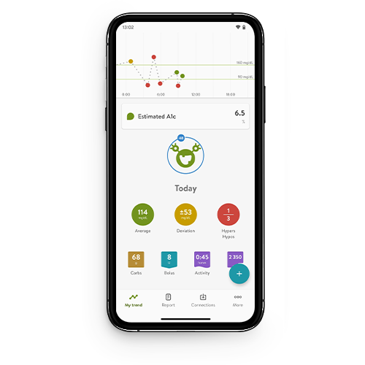
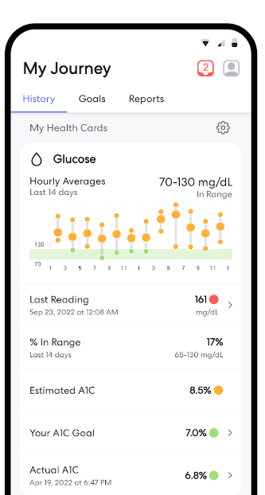
Figure 3 MySugar

Figure 4 One drop app

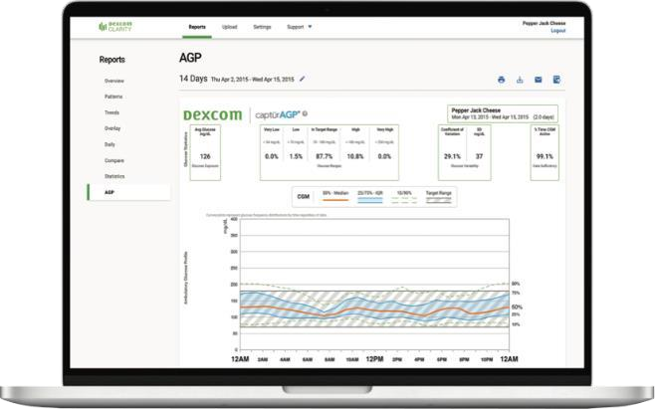
Figure 5 Dexcom Clarity

Chapter 3

Materials and Methods

3.1 System Description

System Context
The system has been crafted to offer a self-care solution tailored for the management of diabetes. It caters to individuals dealing with diabetes who are in search of effective tools to enhance treatment adherence and monitor their health. The system is seamlessly connected with users and external databases to efficiently collect and manage pertinent health information.

System Boundaries
The system has many components for the user such as registration, authentication, management of personal health records (PHR), real-time data monitoring, personalized meal planning, medication tracking, and a user-friendly chat interface. The system seamlessly interacts with external elements, such as healthcare databases, for validating data and adhering to medical guidelines during result interpretation.

3.2 System Requirements

The diagram illustrates the features of a comprehensive diabetes management system, a self-care platform designed to streamline diabetes management. The system begins with a menu offering options such as Profile, Pre-diabetes, Diabetes, Living Well, About, Chat, and Prediabetes. Users can insert their information in the system through three main actions: Upload File, Enter Data Manually, and Scan Image. Following data entry, users can fill out a Questions Form, or Request to Open the Camera, ultimately leading to the "See Your Results" section where medical data interpretations and recommendations are provided. This interconnected workflow, encompassing pivotal features such as user registration, data monitoring, meal planning and nutrition guidance, insulin management tools, test report interpretation, and an interactive communication chat section, aims to comprehensively address the multifaceted aspects of diabetes. The system equips patients with tools for tracking their conditions, thereby enhancing their quality of life and fostering a sense of control over their health.
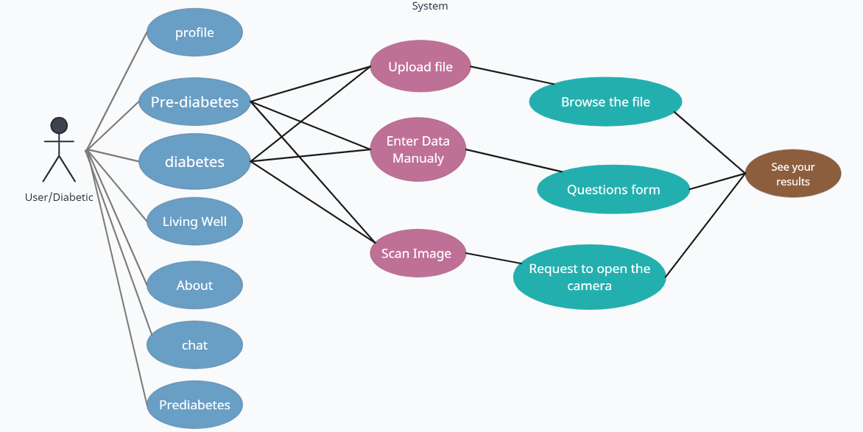
Figure 6 A simple photo of the use case
Network interfaces.

Network interfaces are essential in promoting communication among different components.
: The following is a summary of network interfaces that are pertinent to the system

- HTTP/HTTPS Protocol
Objective: Typical messages among the chatbot, server, and website. users, retrieving basic chatbot data, and sending non-real-time data are just a few examples of the typical data interchange scenarios that make use of HTTP/HTTPS protocols.
Application: To retrieve or transmit data, such as user preferences, chat history, or system upgrades, the website sends HTTP requests to the server.
- Secure Socket Layer (SSL)
Objective: SSL protocols are utilized to encrypt data transmitted between the website's chatbot and the server, safeguarding sensitive user information and maintaining privacy.
Application: SSL certificates are implemented on the server to establish secure connections.

- Software Interfaces

User Interface (UI): Users can enter and see diabetes management data on the DMS website, which has an intuitive UI.
Web Browser Interface: The DMS can be accessed by users from a variety of internet-connected devices thanks to the website's interaction with web browsers.

Non-Functional Attributes

1-Security
To protect user data, the website should use encrypted communication (HTTPS), secure login methods, and access controls.
2-Reliability
Data integrity should be preserved, and the system should be accessible with little interruption.
3-Maintainability
To enable updates, code needs to be modular, well-documented, and well-structured.
4-Portability
The system should be compatible with web browsers and responsive to different screen sizes.

3.3 Research Design
Project Planning

- Define scope, objectives, and requirements.

- Identify target audience and user personas.

- Create a project timeline.

- Set a budget and allocate resources.

- Choose a technology stack for the webpage, camera, and chat component.

Research and Analysis

- Research existing diabetes care systems.

- Analyze user needs and pain points.

- Conduct user interviews.

- Define key features and functionalities.

Design, Home Page, and Login Page

- Create a home page and login page.

- Design user interface.

- Implement data validation and security.

- Develop wireframes and prototypes.

Front-end and Backend Development

- Develop web pages with responsive design.

- Set up the server for data storage.

- Implement image upload function.

- Ensure data validation and error handling.

- Ensure user authentication and data security.

Camera Integration- Image Processing-Data Extraction and Validation

- Integrate camera functionality.

- Implement image processing module.

- Utilize OCR for data extraction.

- Verify the accuracy of extracted data.

- Test usability and optimize performance.

Data Integration

- Integrate with medical databases.

- Develop APIs for secure data retrieval.

- Ensure data accuracy and confidentiality.

Data Entry Page

- Create a secondary page for data entry.

- Develop a form for manual data entry.

- Ensure data validation and error handling.

Report Presentation

- Design UI for displaying medical reports.

- Implement interactive charts and graphs.

- Develop features for sorting, filtering, and searching reports.

- Assure responsiveness and accessibility.

User Profile Management

- Create a user profile page for viewing and editing information.

- Implement options for updating contact details and preferences.

- Ensure data validation and security for user profile changes.

Content Research and Collection - Content Organization and Structure

- Gather accurate information about diabetes management.

- Create a clear and logical structure for presenting instructions.

- Develop high-quality written content.

- Design an easy-to-use diabetes advice page.

- Design a user-friendly web page layout.

- Use responsive design for accessibility.

Chat

- Collect accurate information about diabetes.

- Compile a database of common questions and answers.

- Implement NLP for chatbot understanding.

- Train chatbot using diabetes knowledge.

- Design a user-friendly chatbot interface.

- Implement responsive design.

- Design a funnel for diabetes-related questions.

- Implement a chat interface.

Deployment

- Prepare the system for production deployment.

- Deploy the system on a web server.

- Configure domain and hosting settings.

- Perform final testing.

Post-launch Maintenance and Support

- Provide ongoing support and updates.

- Monitor system performance and security.

Research Methods - Techniques

- Medical Diagnosis and Etiological Factors Assessment:
Method: Medical Studies
Techniques:
- Regular Monitoring: Scheduled assessments every 3 to 6 months for clinical monitoring.
- Confirmatory Assessments: HbA1c and blood glucose measurements.
- Etiological Factors Assessment: Analyze family history, age at onset, physical characteristics, and presence of islet autoantibodies.
- Classification: Categorize diabetes into types 1, 2, and gestational

- Image Processing and Data Extraction
Method: Computer Vision and Optical Character Recognition (OCR)
Techniques:
- Image Upload: Allow users to upload images for analysis.
- Image Scanning: Capture and process images using OpenCV.
- OCR: Utilize Tesseract OCR for extracting text from scanned images.
- Data Verification: Implement algorithms to verify the accuracy of extracted data.

- Chatbot Development
Method: Natural Language Processing (NLP)
Techniques:
- Dataset Collection: Collect diabetes documents in various formats for training.
- Language Model Selection: Choose pre-trained language models from Hugging Face Transformers.
- User Interaction: Implement a chat interface for asking questions about diabetes.

- System Development
Method: Software Development
Techniques:
- Front-end Development: Use HTML, CSS, and JavaScript to create a web page.
- Back-end Development: Employing a database to handle data storage and processing.

- Testing and Validation
Method: Software Testing
Techniques:
- Unit Testing: Test individual components for correctness.
- User Testing: Engage users for feedback on usability and functionality.
- System Validation: Validate the overall effectiveness of medical diagnosis, clustering, and chatbot components.

- Deployment and Maintenance
Method: System Deployment and Maintenance
Techniques:
- Production Deployment: Deploy the system on a web server.
- Post-launch Maintenance: Provide ongoing support, troubleshoot issues, and plan for regular updates.

3.4 Architectural Design
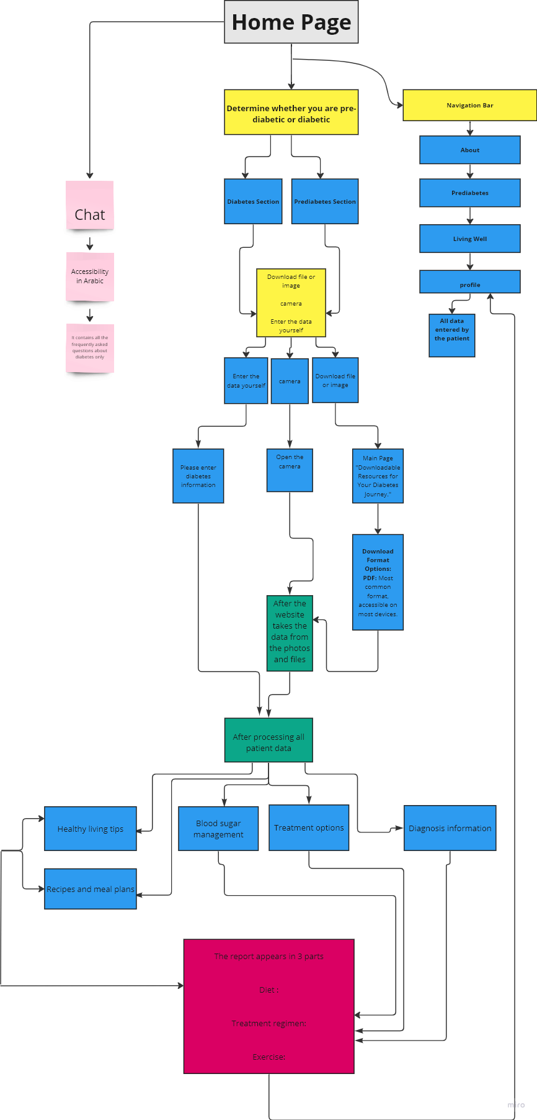

Figure 7 System diagram

 | This color represents the first website, which is the Home Page.
 | This color represents the sub-parts that the patient can choose on the website.
 | This color represents the basic parts of the website
 | This color represents the hidden parts that the patient can see when using the website (Note that it is written for clarification only).
 | This color represents only the part of the chat that can help the patient with any information about diabetes.
 | This color represents the final part of the website.

A simple explanation of the diagram:
1-Home page
- A split image representing both prediabetes and diabetes. On one side, a person enjoys a healthy meal and exercise, and on the other, someone checks their blood diabetes.
- The headline is “Empowering Your Diabetes Journey”
- Subheading: "Find reliable information, and support to your stage of diabetes."
2-Navigation bar
- About: Understand the basics, types, causes, and risk factors.
- Prediabetes: Learn about the warning signs, prevention strategies, and lifestyle changes.
- Living Well: Discover tips for healthy eating, physical activity, and mental well-being.
- Profile: It contains all patient data.
3-Prediabetes Section
- Actionable tips: Give helpful tips on managing weight, nutrition, and exercise to help reverse prediabetes.
4-Diabetes Section
- Treatment options: Investigate prescription drugs, insulin therapy, and further management strategies.
- Blood sugar management: Provide information about goal setting, blood sugar monitoring, and medication adjustments.
- Recipes and meal plans: Provide scrumptious, healthful recipes that are appropriate for those with prediabetes and diabetes.
- Exercise routines: Provide training schedules that are tailored to the needs and fitness levels of each client.
5-Chatbot
- Dataset Collection and Preparation
Data Sources: Various document formats (PDFs, DOCX, TXT, CSV) containing information related to diabetes were collected.

- Preprocessing Steps: Extract text content from documents using specific loaders for each file format (PyPDFLoader, Docx2txtLoader, TextLoader, CSVLoader). Splitting the text into manageable chunks using the CharacterTextSplitter.

- Developed Conversational Retrieval Chain using Langchain:
Integrated the language model, memory handling (ConversationBufferMemory), and document-based retrieval (Chroma) into the chain. Defined a system prompt for guiding the responses related to diabetes information in Arabic.

- Implementation Details – Streamlit Integration: Implemented a Streamlit-based user interface. Integrated functionalities for file uploading, document processing, and displaying chat history. – GridSearchCV: This was used to find the best values for these parameters. – User Interaction: Users can ask questions related to diabetes in Arabic. The system responds by leveraging the configured conversational chain.

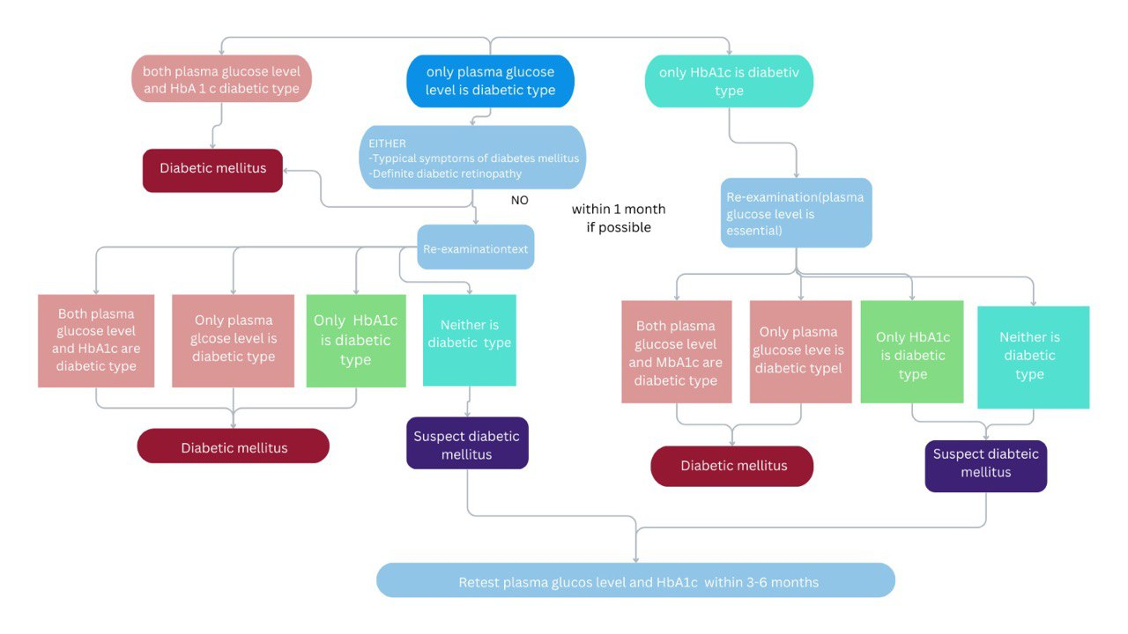
Figure 8 Diabetes Monitoring
- Regular Monitoring: Scheduled assessments every 3 to 6 months to monitor the clinical course of diabetes mellitus; if casual blood glucose ≥200 mg (about twice the weight of a business card)/dL (11.1 mmol/L) during the initial assessment, the patient should undergo alternative tests for subsequent confirmatory assessments. Confirmatory assessments should include both HbA1c and blood glucose measurements to confirm the diagnosis. Close attention is crucial, especially in patients with conditions that may cause discrepancies between the HbA1c and mean glucose values. Diabetes is classified into three primary categories: type 1, type 2, and gestational diabetes.

- A comprehensive evaluation of information is necessary to assess the etiological factors contributing to diabetes.

- Family history: - Understanding a patient's family history helps identify genetic predispositions to diabetes. Genetic factors significantly contribute to the risk of developing type 1 and 2 diabetes. If close relatives have diabetes, this increases the likelihood of an individual developing the condition.

- Age: - The age at which diabetes presents and the progression of the disease can provide insights into the type and severity of diabetes. For example, type 1 diabetes often starts in childhood or adolescence, while type 2 diabetes is more common in adults. The clinical course, whether sudden or gradual, affects treatment strategies.

- Physical characteristics: - Body weight, body mass index (BMI), and overall body composition were significant factors. Excess body weight, especially around the abdomen, increases the risk of insulin resistance, which is a common factor in type 2 diabetes.

- Presence of islet autoantibodies: - In type 1 diabetes, the immune system attacks insulin producing beta cells in the pancreas. The presence of specific autoantibodies against these cells helps differentiate type 1 from type 2 diabetes.

3.5 Data Design

The dataset used was obtained from reliable websites, which contain information about patients suffering from diabetes-related diseases. The first dataset includes more than 8 features. This dataset contains more than 768 patient records, indicating 3 years of healthcare records (2020 to 2023) and the second dataset includes more than 12 features. This dataset contains over 1000 patient records, indicating 3 years of healthcare records (2020 to 2023). Briefly, the information in the dataset refers to hospital admissions and information about 24 medications administered to patients with diabetes. changes in the patient's medications, and whether the dose was increased, decreased, kept stable, or not administered, Giving many medications to the patient.

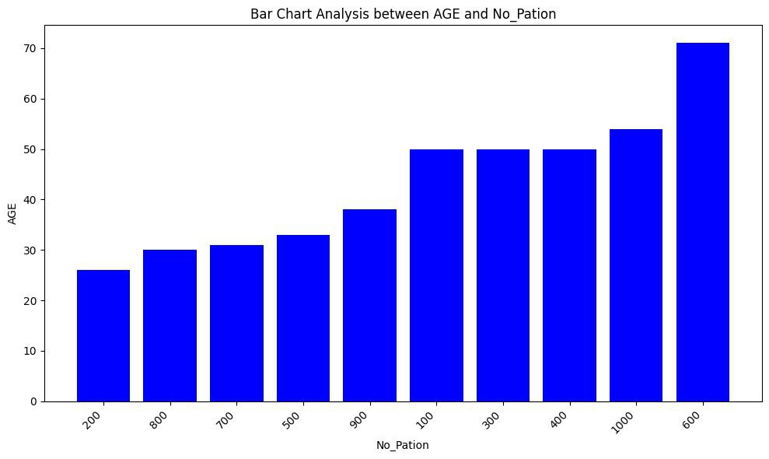
Figure 9 Dataset graph

Dataset 1

Source of dataset: National Institute of Diabetes and Digestive and Kidney Diseases

All patients here are females at least 21 years old.

Number of Instances: 768
Number of Attributes: 9
Number of numeric features: 8
- Pregnant
- Plasma (glucose concentration 2 hours in an oral glucose tolerance test)
- Blood pressure
- Triceps skin fold thickness
- Insulin
- Body mass index
- Pedigree
- Age
Number of symbolic features: 1
- Class variable (tested positive or tested negative)

Description:

PREG | "Pregnant" variable typically refers to the number of pregnancies a person has had and is often referred to as "pregnancies." This variable is part of a patient's medical history and can be used for various purposes in diabetes testing and management:
PLAS | PLAS stands for plasma glucose concentration in a 2-hour oral glucose tolerance test (OGTT). The OGTT is a test used to diagnose diabetes. It involves drinking a sugary drink and then having blood sugar level tested at intervals over 2 hours.
PRES | PRES is the blood sugar level measured before a meal. It is an important part of diabetes management, as it can help to identify people who are at risk for high blood sugar after eating.
SKIN | One way is to measure blood sugar levels through the skin. This is a non-invasive method that uses a small sensor that is placed on the skin. The sensor measures the glucose levels in the interstitial fluid, which is the fluid that surrounds the cells.
INSU | INSU stands for insulin. It is a hormone produced by the pancreas and helps control blood sugar levels. People with diabetes have problems with their insulin production or insulin sensitivity, which can lead to high blood sugar levels
MASS | MS can be used to measure the levels of different molecules in the blood, including glucose, insulin, and other hormones. This information can be used to get a more complete picture of blood sugar control.
PEDI | Diabetes Pedigree Function (DPF) is used to assess the hereditary risk of diabetes by quantifying an individual's family history of diabetes.

preg | plas | pres | skin | insu | mass | pedi | age | class
6 | 148 | 72 | 35 | 0 | 33.6 | 0.627 | 50 | tested_positive
1 | 85 | 66 | 29 | 0 | 26.6 | 0.351 | 31 | tested_negative
8 | 183 | 64 | 0 | 0 | 23.3 | 0.672 | 32 | tested_positive
1 | 89 | 66 | 23 | 94 | 28.1 | 0.167 | 21 | tested_negative
0 | 137 | 40 | 35 | 168 | 43.1 | 2.288 | 33 | tested_positive
5 | 116 | 74 | 0 | 0 | 25.6 | 0.201 | 30 | tested_negative
3 | 78 | 50 | 32 | 88 | 31 | 0.248 | 26 | tested_positive
10 | 115 | 0 | 0 | 0 | 35.3 | 0.134 | 29 | tested_negative
2 | 197 | 70 | 45 | 543 | 30.5 | 0.158 | 53 | tested_positive
8 | 125 | 96 | 0 | 0 | 0 | 0.232 | 54 | tested_positive
. . . . . . . . .
. . . . . . . . .
. . . . . . . . .
. . . . . . . . .
. . . . . . . . .
. . . . . . . . .
3 | 100 | 68 | 23 | 81 | 31.6 | 0.949 | 28 | tested_negative
1 | 100 | 66 | 29 | 196 | 32 | 0.444 | 42 | tested_negative
5 | 166 | 76 | 0 | 0 | 45.7 | 0.34 | 27 | tested_positive
1 | 131 | 64 | 14 | 415 | 23.7 | 0.389 | 21 | tested_negative
4 | 116 | 72 | 12 | 87 | 22.1 | 0.463 | 37 | tested_negative
4 | 158 | 78 | 0 | 0 | 32.9 | 0.803 | 31 | tested_positive
2 | 127 | 58 | 24 | 275 | 27.7 | 1.6 | 25 | tested_negative

Dataset 2

Source of dataset: Rashid, Ahlam (2020), “Diabetes Dataset”, Mendeley Data, V1
The data were collected from the Iraqi society.
Number of Instances: 1000
Number of Attributes: 14
Number of numeric features: 12
- No. of Patient
- ID
- Age
- Urea
- Creatinine ratio (Cr)
- HBA1C
- Cholesterol (Chol)
- Triglycerides (TG)
- HDL
- LDL
- VLDL
- Body Mass Index (BMI)

Number of symbolic features: 2
- Gender (Male, Female)
- Class variable (N = Non-Diabetic, P = Predict-Diabetic, Y = Diabetic)

Description:

Urea | While urea is not a diagnostic marker for diabetes, it may be measured in individuals with diabetes as part of a comprehensive metabolic panel or basic metabolic panel to assess kidney function and overall health. Kidney function is important to monitor in people with diabetes because diabetes can lead to diabetic nephropathy, a kidney complication.
Cr | Creatinine is a waste product produced by muscles during their normal breakdown. While creatinine itself is not a direct indicator of diabetes, it is commonly measured in individuals with diabetes to assess kidney function and diabetic nephropathy monitoring
HbA1c | HbA1c serves as a valuable marker for assessing average blood glucose levels over the past 2-3 months. This extended time limit makes it an essential tool for evaluating long-term glycemic control.
Chol | While cholesterol levels are not typically part of the standard diabetes test, they are often assessed in a routine health checkup or as part of a broader assessment of cardiovascular risk factors in individuals with diabetes.
LDL | Often referred to as "bad" cholesterol, it carries cholesterol to the arteries and can lead to plaque buildup
HDL | Known as "good" cholesterol, it helps remove cholesterol from the bloodstream
VLDL | Provide valuable information in the context of diabetes care and overall cardiovascular risk assessment.
Triglycerides (TG) | Another type of fat in the blood that can increase cardiovascular risk when elevated.
BMI | It is a valuable indicator and risk factor associated with the development and management of diabetes.

AGE | Urea | Cr | HbA1c | Chol | TG | HDL | LDL | VLDL
50 | 4.7 | 46 | 4.9 | 4.2 | 0.9 | 2.4 | 1.4 | 0.5
26 | 4.5 | 62 | 4.9 | 3.7 | 1.4 | 1.1 | 2.1 | 0.6
50 | 4.7 | 46 | 4.9 | 4.2 | 0.9 | 2.4 | 1.4 | 0.5
50 | 4.7 | 46 | 4.9 | 4.2 | 0.9 | 2.4 | 1.4 | 0.5
33 | 7.1 | 46 | 4.9 | 4.9 | 1 | 0.8 | 2 | 0.4
45 | 2.3 | 24 | 4 | 2.9 | 1 | 1 | 1.5 | 0.4
50 | 2 | 50 | 4 | 3.6 | 1.3 | 0.9 | 2.1 | 0.6
34 | 3.9 | 81 | 6 | 6.2 | 3.9 | 0.8 | 1.9 | 1.8
34 | 3.9 | 81 | 6 | 6.2 | 3.9 | 0.8 | 3.8 | 1.8
34 | 3.9 | 81 | 6 | 6.2 | 3.9 | 0.8 | 3.8 | 1.8
31 | 3.4 | 55 | 5.7 | 4.9 | 1.6 | 1 | 3.2 | 0.7
34 | 3.9 | 81 | 6 | 6.2 | 3.9 | 0.8 | 1.9 | 1.8
.
.
.
.
.
.
.
31 | 3.4 | 55 | 5.7 | 4.9 | 1.6 | 1 | 3.2 | 0.7
43 | 2.1 | 55 | 5.7 | 4.7 | 5.3 | 0.9 | 1.7 | 2.4
31 | 3 | 60 | 12.3 | 4.1 | 2.2 | 0.7 | 2.4 | 15.4
30 | 7.1 | 81 | 6.7 | 4.1 | 1.1 | 1.2 | 2.4 | 8.1
45 | 4.1 | 63 | 10.2 | 4.8 | 1.3 | 0.9 | 3.3 | 9.5
45 | 4.1 | 63 | 10.2 | 4.8 | 1.3 | 0.9 | 3.3 | 9.5
45 | 5.3 | 77 | 11.2 | 3.9 | 1.5 | 1.3 | 2 | 10.4
31 | 3.4 | 55 | 6.5 | 4.9 | 1.6 | 1 | 3.2 | 0.7
45 | 5.3 | 77 | 11.2 | 3.9 | 1.5 | 1.3 | 2 | 10.4

3.6 Interaction Design

This is a flowchart for the system. It starts by asking the user to choose how they want to enter their information. Then, it asks the user if they are diabetic or pre-diabetic. If they are pre-diabetic, it directs them to recommendations for pre-diabetes. If they are diabetic, it asks them if they know what they have been diagnosed with and what type of diabetes they have. It directs them to recommendations for either type 1 or type 2 diabetes, depending on their diagnosis. If they have not been diagnosed, it directs them to another question.

If the user does not know the type of diabetes he/she has, the system asks them for their gender and whether they are pregnant. If they are pregnant, it directs them to recommendations for gestational diabetes. Otherwise, it directs them to recommendations for either type 1 or type 2 diabetes, depending on their diagnosis.
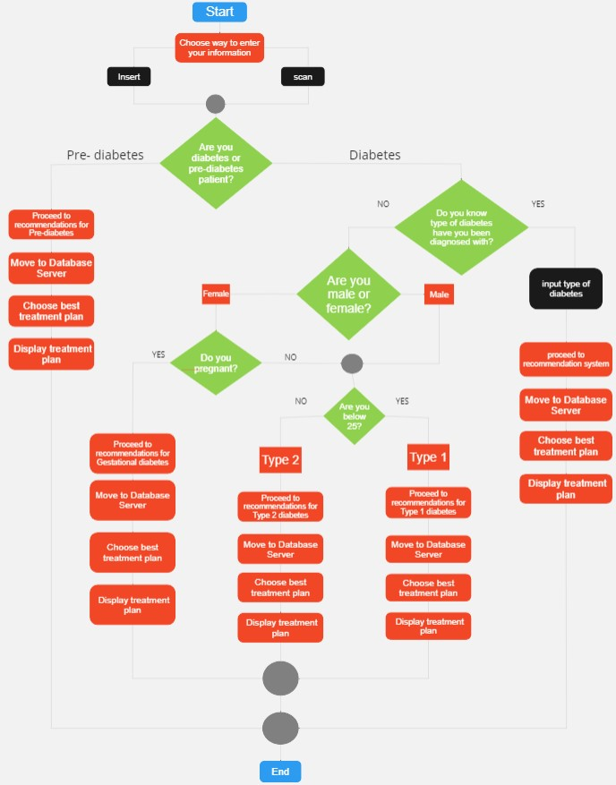
Figure 10 Flowchart of the system

Chapter 4

Implementation and Preliminary
Results

4.1 Programming Languages and Tools

Python

Python is a widely used programming language known for its readability and simplicity. It is an excellent choice for backend development due to its extensive support through Django, a high-level web framework that facilitates rapid development, follows best practices, and offers features like ORM, form handling, and built-in security mechanisms.

Django Framework

Django is a high-level web framework for Python that follows the Model-View-Controller (MVC) architectural pattern. It provides a well-organized structure, robust security features, and built-in tools for common tasks like database modeling (ORM), user authentication, and URL routing. The Django admin panel also simplifies backend administration tasks.

HTML, CSS, JavaScript
These are fundamental web technologies for front-end development. HTML provides the structure, CSS styles the presentation, and JavaScript adds interactivity to the user interface. Using these technologies ensures a responsive and user-friendly web application.

OpenCV (Open-Source Computer Vision Library)
OpenCV is used for image processing and computer vision tasks. In this project, it can be employed for capturing and processing images from the camera during the image scanning process, contributing to the overall functionality of the diabetes management system.

Tesseract OCR
Tesseract OCR is an open-source optical character recognition engine. It is utilized for extracting text from scanned images, a crucial aspect in the image processing module of the system. Tesseract's accuracy and robustness make it suitable for this task.

Hugging Face Transformers
Hugging Face Transformers provides pre-trained natural language processing models that can be utilized for chatbot development. The models, such as LLAMA-2-70B-Chat and MiniLM-L6-v2, offer efficient language understanding and generation capabilities, saving development time and ensuring high-quality responses.

Streamlit
Streamlit is a Python library for creating interactive web applications with minimal code. It can be employed for building the user interface, facilitating quick iterations, and providing a seamless experience for users interacting with the system.

Matplotlib
Matplotlib is a popular data visualization library for Python. In this project, it can be used to visualize scanned images in the Tkinter window during the image scanning process, enhancing the user experience.

LLAMA-2-70B (Model Setup and Configuration – Language Model)
Utilized LLAMA-2-70B-Chat and MiniLM-L6-v2 from Hugging Face Transformers – Embeddings and Vector Stores: Hugging Face Embeddings for text representation. Chroma vector store created from document chunks using embeddings. – System Configuration: Configured the language model (LLM) for streaming and optimized settings (temperature, maxlength) for effective conversational responses.
SQL
Structured query language (SQL) is a programming language for storing and processing information in a relational database.

4.2 Code Structure

The codebase is organized and modularized using a combination of the Django project structure and the concept of Django apps. Here is an explanation of how the code is organized and modularized:
The codebase follows the standard Django project structure, which includes top-level files and directories such as `manage.py`, `settings.py`, `urls.py`, and `wsgi.py` or `asgi.py`. These files provide the overall configuration and entry points for the Django project. The codebase is modularized into separate Django apps, each responsible for a specific functionality or feature of the website. Each app is typically organized as a directory within the project. For example:

- Each app has its own `models.py` file, where the Django models for that app are defined. Models represent the data structures and database tables specific to the app.
- The `views.py` file in each app contains the Python code that handles HTTP requests and generates responses for that app.
- The `urls.py` file in each app defines the URL routing specific to that app, mapping URLs to corresponding views or endpoints within the app.
- The `templates/` directory within each app holds the HTML templates used for rendering dynamic content related to that app.
- The `static/` directory within each app contains static files (CSS, JavaScript, images, etc.) specific to that app.

The codebase has shared components or modules that are used across multiple apps or the entire codebase. These components can be organized in a separate directory, such as `utils/`, `common/`, or `shared/`. Shared components include utility functions, helper classes, or other reusable code used across the project. The codebase relies on external dependencies and libraries, such as Django packages or third-party libraries. These dependencies are typically managed using package management tools like pip (for Python dependencies) or npm (for JavaScript dependencies). By organizing the codebase into separate Django apps and utilizing shared components, the code becomes modular and easier to maintain. Each app focuses on a specific functionality, making it easier to understand and modify. Shared components promote code reuse and help avoid duplication of code across multiple apps. This modular organization also facilitates collaboration among team members.

4.3 Data Structures and Databases

4.3.1 Data Structures

Patient Registration
- Attributes: Username, Email, Password, Date of Birth, Gender, Contact Information
- Description: Stores personal information and login credentials for each user. Ensures secure authentication and personalized user experience.

Patient Information
- Attributes: Blood Sugar Levels, Medication Records, Insulin Dosages, HbA1c, Urea, Cr, TG, LDL, HDL, VLDL, Chol, and BMI.
- Description: Maintains comprehensive health records for each user, including historical data on blood sugar levels, and medications, also includes key health metrics provided by the patient (Medical test report result).

Nutrition and Treatment Planning
- Attributes: Plan Number, Diabetes Type, Meal Details (e.g., Breakfast, Lunch), Treatment Information, Recommended Serving Sizes.
- Description: Stores Treatment plans and nutritional guidelines tailored to each Patient's health profile.

Exercise and Activity Logs
- Attributes: Activity Type (e.g., Walking, Running), Duration, Intensity.
- Description: Tracks physical activities and exercise routines, helping users monitor their physical activity and its impact on blood glucose levels.

Chatbot
- Attributes: Message Content, Response Content, Timestamp
- Description: Records interactions between users and the AI-powered chat system, ensuring users receive accurate and contextually relevant responses to their inquiries.

4.3.2 Databases

- Patient data was entered into database systems, including a profile file with the patient's email address and password. A notification informing the patient that the email address or password was incorrect would show if they typed it incorrectly.

- It stores information about physical activity, nutrition, and treatment plans.

- Medical Records: Keep track of your medical history, including test results (HbA1c, blood sugar levels), prescriptions (insulin dosage, oral drugs), treatment regimens, and doctor's comments.

- Blood Sugar level readings: The site stores the sugar level to give the patient important advice about his condition.

4.4 Experimental Setup
- Login page
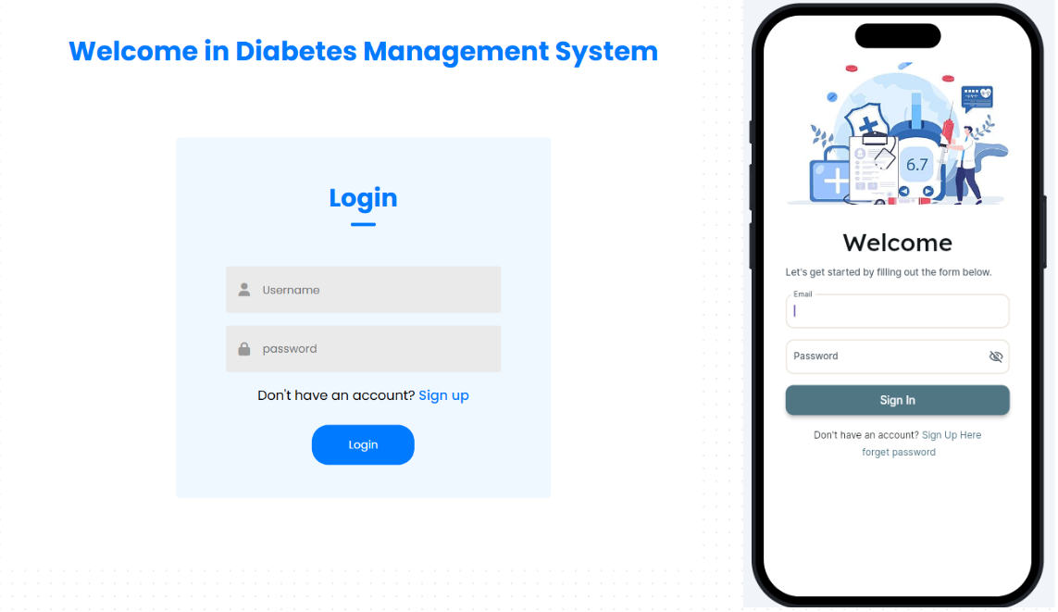
Figure 11 Login page

The team has designed and implemented a comprehensive user interface for the website or system. A visually engaging home page has been created to introduce the purpose of the platform. The login and registration pages provide a user-friendly experience with secure data handling. The intuitive design encourages users to enter information easily, supported by robust data validation and security measures. Mechanisms for saving and restoring data have been implemented for user convenience. Password management and email verification strategies enhance security. The commitment to delivering an exceptional user interface results in an intuitive, visually appealing, and user-friendly system.
- Sign Up Page
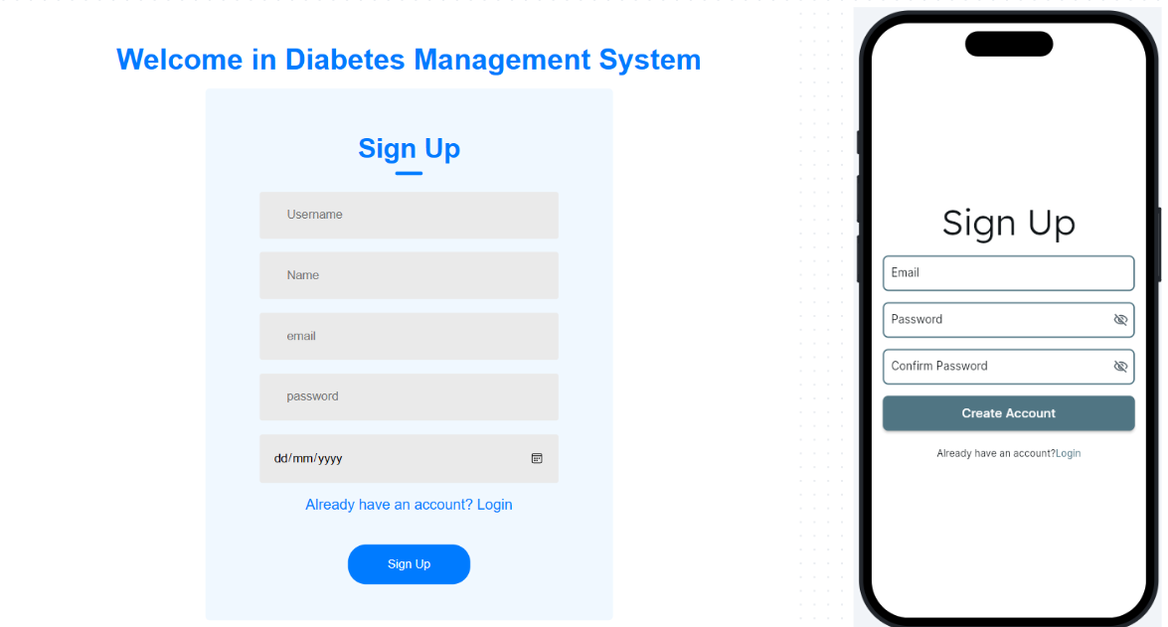
Figure 12 Sign Up Page

The sign-up page of the Diabetes Management System (DMS) website is designed to facilitate and secure registration for new users. The patient will input his/her information into each of the following fields. Below the form, there is a link for users who have an account and asks them "Already have an account?" which redirects them to the login page. This ensures that users who already have an account can easily access their profiles without having to go through the sign-up process again.

- Diabetes Follow-up Page
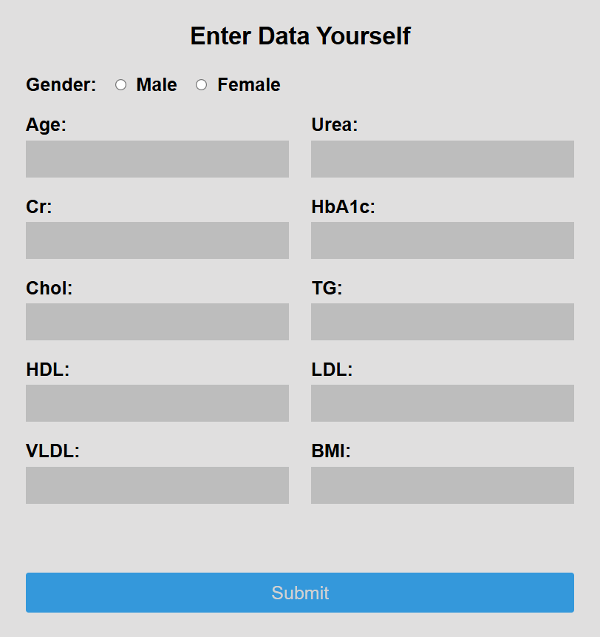
Figure 13 Data Entry page
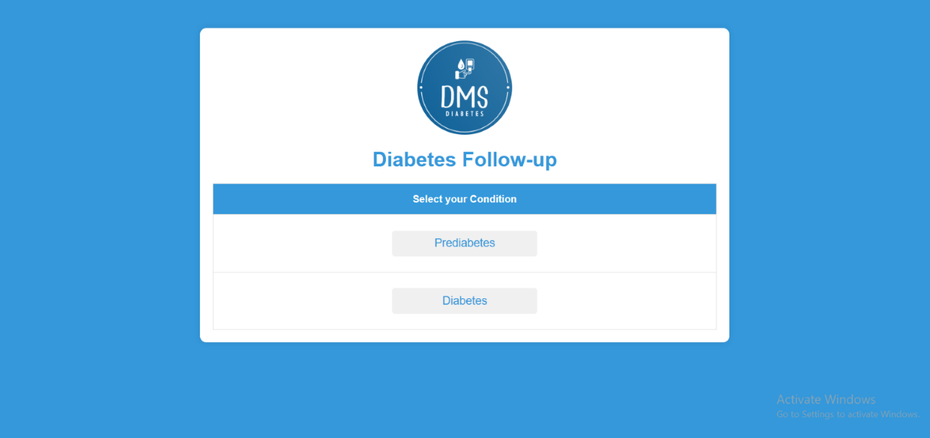

Figure 14 Diabetes Follow-Up Page

The user is prompted to "Select your Condition" from the two options provided. The first option is labeled "Prediabetes," and the second option is labeled "Diabetes."

When a user selects the "Prediabetes or Diabetes" option from the Diabetes Management System (DMS) homepage, they are directed to a dedicated page for monitoring and managing if he/she pre-diabetic or diabetic condition. This page is designed to gather essential health information and symptoms to tailor the user's care plan effectively. Upon arrival, the user is prompted to enter their basic health metrics as shown in figure 13.

- Exercises Page

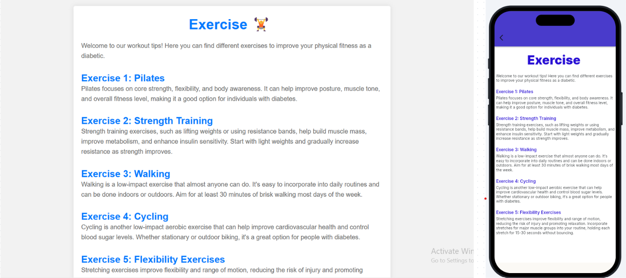

Figure 15 Exercises Page

The exercise page of the Diabetes Management System (DMS) website is designed to provide diabetic patients with various workout tips to improve their physical fitness. This page features a clean and informative layout with a welcoming introduction and a list of exercises suitable for individuals' managing diabetes. Regular physical activity is crucial for diabetes management, helping to control blood sugar levels, improve cardiovascular health, enhance overall well-being, and reduce the risk of diabetes-related complications.

- Instructions Page

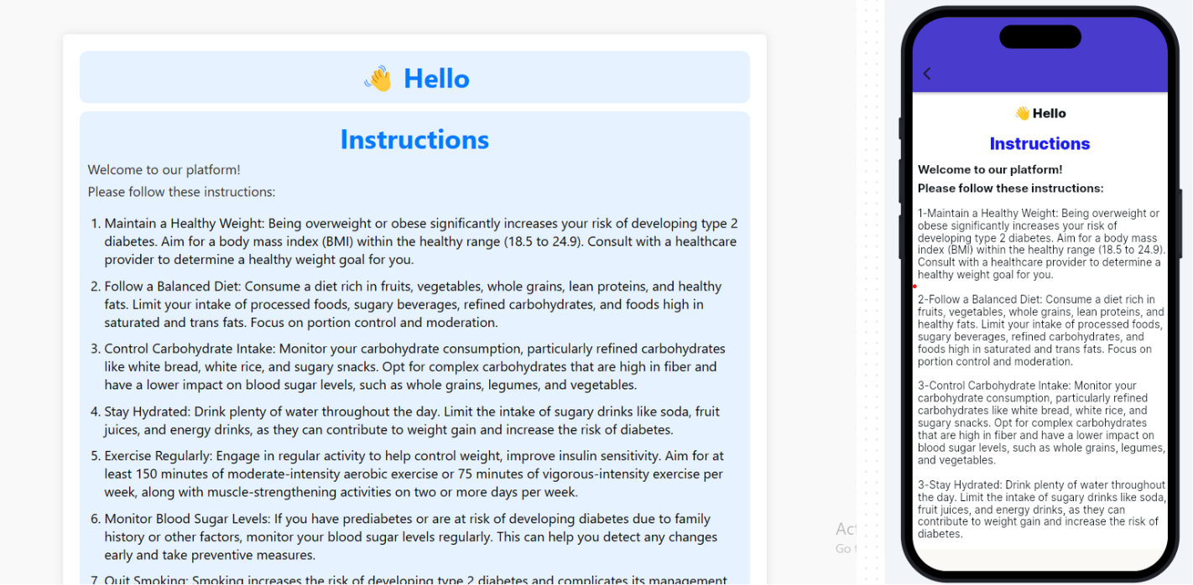

Figure 16 Instruction Page

The instructions page of the Diabetes Management System (DMS) website is designed to provide diabetic patients with essential advice on how to live with and manage diabetes effectively. This page offers a comprehensive guide with practical tips aimed at improving overall health, controlling blood sugar levels, and reducing the risk of diabetes-related complications.

- Insert Information Page

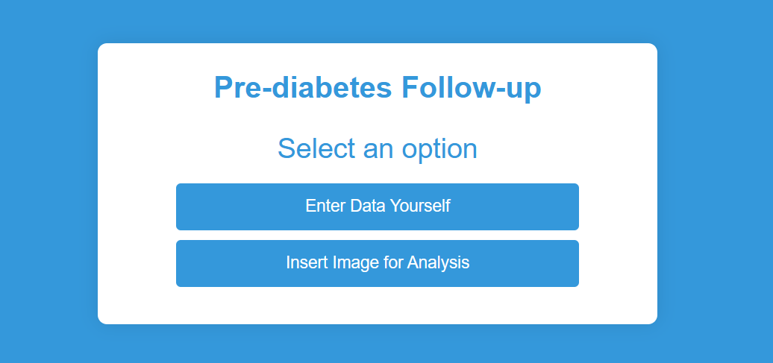

Figure 17 Information Insertion

The image displays a user interface for a diabetes management system and this interface prompts the user to select how they want to input their information, offering two options. The first option is labeled "Enter Data Yourself," allowing the user to manually input their data. The second option is labeled "Insert Image for Analysis," enabling the user to upload an image of their medical test results for automated analysis.

- Treatment Plan Page

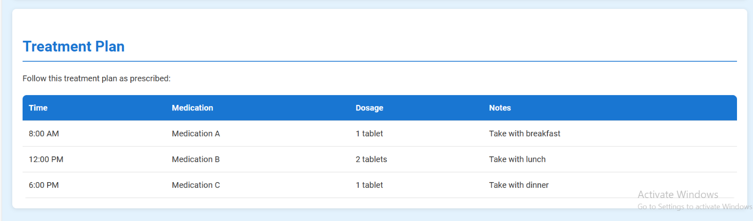

Figure 18 Treatment plan Page

The image shows a section of the diabetes management system that outlines a treatment plan for diabetes patients. The plan is organized in a table format with four columns: Time, Medication, Dosage, and Notes.

- Time: Indicates the scheduled times for taking medication

- Medication: Specifies the name of the medication to be taken

- Dosage: The amount of medication to be taken at each time

- Notes: Provides additional instructions related to the medication intake

- Diet plan

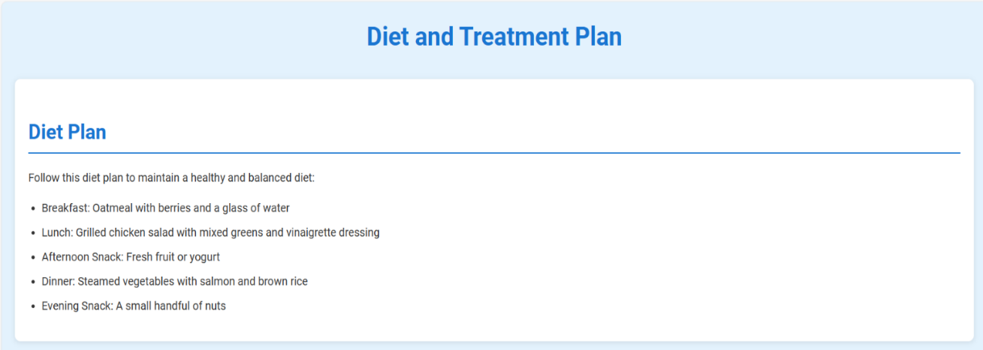

Figure 19 Diet plan page

The image displays a section of the diabetes management system dedicated to providing a diet plan for diabetes patients. Diet is crucial for diabetes patients as it helps regulate blood glucose levels, maintain a healthy weight, and ensure adequate nutrition. Proper dietary management prevents blood sugar spikes and dips, supports weight control, and reduces insulin resistance. A balanced diet rich in essential nutrients, including vitamins, minerals, and fiber, can prevent complications such as heart disease, stroke, kidney disease, and neuropathy.

- Patient information page
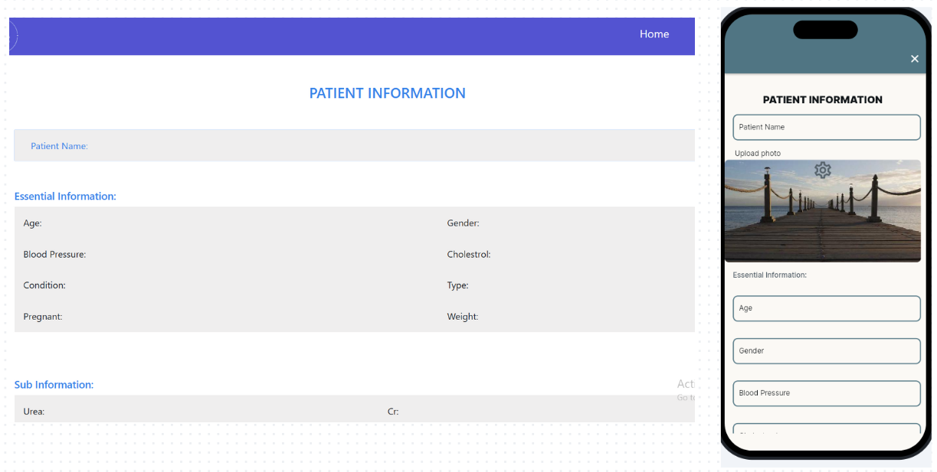
Figure 20 Patient Information Page

- Creating a comprehensive user profile page for patients is pivotal to providing a seamless healthcare experience. This system allows patients to effortlessly access and manage their personal information while ensuring data accuracy and security. Through this user-friendly interface, patients can easily view and edit their details, including personal information and their treatment plan, thereby ensuring that their records remain up-to-date and reflective of their status.

- Create a user profile page where patients can view and edit their personal information.

- Prediction Result

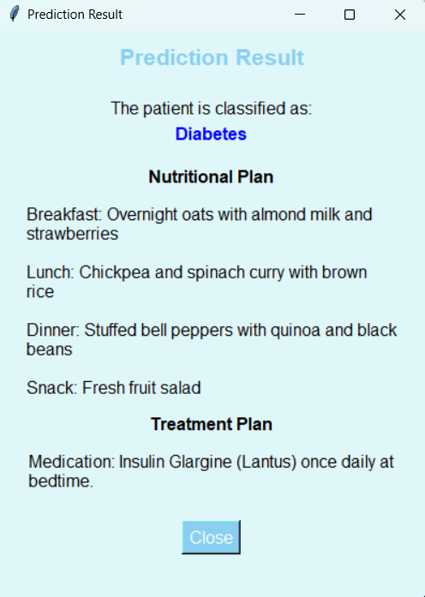

Figure 21 Prediction Result

This page shows the prediction result, which displays the outcome of the diabetes classification based on the patient's input. also display a comprehensive plan that outlines a personalized approach to managing the patient's diabetes, combining a targeted nutritional plan to help regulate blood sugar levels along with the appropriate medication therapy. The goal is to provide the patient with a clear roadmap for effective diabetes management and improved health outcomes
- Chatbot

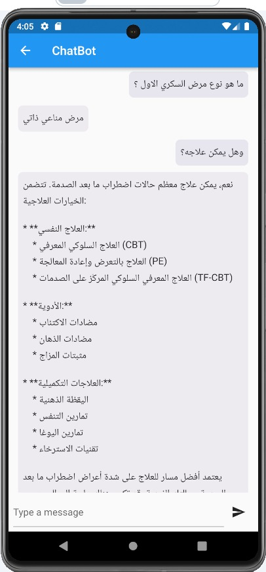

Figure 22 Chatbot

- Developed an AI-powered chatbot system to enhance patient support and provide immediate responses to inquiries related to diabetes management. The chatbot is designed to answer a wide range of questions, ensuring patients have access to reliable information.

- Utilizes NLP to understand and respond to patient queries in several languages, making the interaction more intuitive and user-friendly

Chapter 5

Discussion

5.1 Interpretation of Results

The diabetes management system, including the AI-powered chatbot, was tested extensively to evaluate its performance, usability, and overall effectiveness in aiding diabetes management. The following sections detail the findings from these tests:

- Usability and User Experience

- Ease of Use
- The system was designed with a user-friendly interface, making it easy for users to navigate and utilize the platform effectively.

- Chatbot Interaction
- Users interacted with the chatbot to ask various questions related to diabetes management, treatments, and lifestyle adjustments.
- The chatbot's ability to understand and respond accurately to questions in Arabic significantly enhanced user satisfaction.

- Data Accuracy and Reliability
- The system efficiently managed and stored critical medical metrics such as HbA1c, Urea, Creatinine, Triglycerides, LDL, HDL, VLDL, Cholesterol, and BMI.
- Users could log their medical information, which was then used to provide personalized recommendations
- The system's ability to analyze data over time helped users identify patterns in their blood sugar levels and make informed decisions about their diet, exercise, and medication.

- System Performance
- The system demonstrated excellent performance in terms of response time. Patients' queries to the chatbot were answered promptly, and data retrieval operations were performed efficiently.
- The backend infrastructure, supported by robust databases and efficient algorithms, ensured that the system could handle multiple concurrent users without performance degradation.

- The system empowered users by giving them tools and information to manage their diabetes more effectively. This led to improved adherence to treatment plans and healthier lifestyle choices.
- Users felt more in control of their health, which positively impacted their overall well-being and quality of life.

5.2 Comparison with Previous Studies

When evaluating alternative platforms, it became clear that they presented challenges for diabetics, emphasizing the significance of offering a simple service

- The reception of patient testing lacked diversity elsewhere, forcing it to widen the sources to include data and photos.

- Many diabetes patients' queries remained ignored on other platforms, prompting the development of an artificial intelligence-powered chat system.

- Other sites lacked sufficient patient follow-up on treatment plans and food planning, which were addressed to ensure patients received adequate care.

- Other platforms lacked diabetes-related advice, so created a website with a variety of information and help.

5.3 Limitations

- The most important limitation faced was how to provide an easy, simple, and effective service to a diabetic patient. One notable limitation was the variety of data formats and quality provided by patients when uploading test files or images.

- The limitation that is also faced is how a diabetic patient can find an answer to any question related to diabetes. Therefore, a chat feature has been provided in the artificial intelligence system, and a lot of advice and guidance related to diabetes has also been provided.

- Another limitation is how this site covers all types of diabetes, whether type 1, type 2, pregnancy, or prediabetes.

- All these restrictions resulted in working to improve the site to provide a wonderful service for diabetics that saves them a lot and helps them with their illness.

Chapter 6

Conclusion and Future Work

6.1 Summary of Findings

The findings from the development and implementation of the Diabetes Management System are extensive and significant in enhancing diabetes self-management. Here’s a summarized overview of the key outcomes:

- The system provides an integrated approach to managing diabetes, which includes user registration, a personal health records system, real-time data monitoring, personalized meal planning, and effective medication management.

- The system generates treatment planning and nutrition advice tailored to the user’s specific health needs, aiding in better blood glucose level management.

- The inclusion of an interactive chat interface allows for dynamic communication between users and the system, facilitating effective management advice and user education on diabetes care.

- The system empowers individuals by providing the necessary tools and information in an accessible manner, thereby improving their ability to manage their diabetes and enhancing their quality of life.

6.2 Future Work

- Reminders for Medication and Testing: Implement reminders for insulin injections, medication schedules, and blood glucose monitoring to promote consistent adherence.

- Progress Tracking: Enable users to monitor their progress over time, showcasing improvements in blood sugar levels, weight management, and overall well-being.

- Emergency Contacts and Information: Include a feature to store emergency contacts and essential health information in case of unexpected situations.

References

[1] American Diabetes Association, "Standards of medical care in diabetes—2023," Diabetes Care, vol. 46, no. Suppl 1, pp. S1-S193, 2023.

[2] A. Mujumdar and V. Vaidehi, "Diabetes Prediction using Machine Learning Algorithms," Procedia Computer Science, vol. 165, pp. 292–299, 2019, doi: 10.1016/j.procs.2020.01.047.

[3] A. Maria, A. Rocha, C. Sandra, L. Costanzo, and P. Reis, "New Contributions in Information Systems and Technologies," in Proc. of International Conference on ..., pp. xxx-xxx, 20xx (you need to fill in the missing information).

[4] A. Tuppad and S. D. Patil, "Machine learning for diabetes clinical decision support: a review," Advances in Computational Intelligence, vol. 2, no. 2, pp. 1-9, 2022, doi: 10.1007/s43674-022-00034-y.

[5] Centers for Disease Control and Prevention, National diabetes statistics report, 2023. Atlanta, GA: Centers for Disease Control and Prevention, US Department of Health and Human Services, 2023.

[6] F. Z. Syed, "Type 1 Diabetes Mellitus," [Online]. Available: https://emedicine.medscape.com/article/117853-overview?form=fpf#a1 (Accessed on: Jun 19, 2024)

[7] International Diabetes Federation, IDF diabetes atlas, 10th ed. Brussels, Belgium: International Diabetes Federation, 2021.

[8] "IoT and Machine Learning based Self Care System for Diabetes Monitoring and Prediction," IEEE Xplore, [Online]. Available: https://ieeexplore.ieee.org/document/9587681 (Accessed on: Oct. 13, 2023).

[9] K. Kissane, "Prediabetes Foods to Avoid," [Online]. Available: https://www.nutrisense.io/blog/prediabetes-food-to-avoid (Accessed on: Jun 19, 2024)

[10] Mayo Clinic, "Diabetes symptoms, causes, diagnosis, treatment, and lifestyle management," [Online]. Available: https://www.mayoclinic.org/diseases-conditions/diabetes/symptoms-causes/syc-20371444 (Accessed on: Jun 19, 2024)

[11] "Mobile-based decision support system for gestational diabetes mellitus," IEEE Xplore, [Online]. Available: https://ieeexplore.ieee.org/document/8384546 (Accessed on: Jun 19, 2024).

[12] National Institute of Diabetes and Digestive and Kidney Diseases (NIDDK), [Online]. Available: https://www.niddk.nih.gov/ (Accessed on: Jun 19, 2024)

[13] NHS, "Causes of diabetes," [Online]. Available: https://www.nhs.uk/conditions/diabetes/ (Accessed on: Jun 19, 2024)

[14] R. A. Sowah, A. A. Bampoe-Addo, S. K. Armoo, F. K. Saalia, F. Gatsi, and B. Sarkodie- Mensah, "Design and Development of Diabetes Management System Using Machine Learning," International Journal of Telemedicine and Applications, vol. 2020, pp. 1–17, 2020, doi: 10.1155/2020/8870141.

